Theme - Science and Technology for society

Sub Theme - Communication and Transport

Category - 2nd category

No. of participating student - 1

Name - N T Keerrthana

Std - Class 11

School - P S Sr Sec School, Mylapore, Chennai, Tamilnadu

Project Guide/ Teacher - Mr. P Gurumoorthy

Project Title – 3 Wheeled solar scooter

Theory – Solar vehicles are electric vehicles which contain solar cells to power themselves. This vehicle contains a rechargeable battery to store the energy from solar cells. This vehicle can be used as a scooter or cycle. There are folded pedals in the vehicle. The rear wheels are converted to trailing wheels and a hub motor is connected to the front. Solar panel is connected to top of the vehicle, which will act as a charging panel.

Advantages:

* Solar scooter can be charged by eb charger as well as by solar panel (dual).
* Scooter will be driven by front wheel (front wheel – hub motor). As the vehicle is three wheeled and both the rear wheels are trailing wheels. Since differential gears (open/ limited slip) is needed, hub motor cannot be kept on one side. In this vehicle the hub motor is connected to the front (differential is not required and weight can be reduced).
* It can be used by physically handicapped
* Since it is a three wheeled scooter, accident due to skidding possibilities are reduced.

**PARTS OF SOLAR VEHICLE**

Here are some common parts typically found in a solar vehicle:

* Solar Panels: These are the primary components that capture sunlight and convert it into electricity. Solar panels are usually mounted on the top of the vehicle to minimize sun’s exposure and they act as a charging panel (4 solar panels -1.4 KW)
* Battery: Solar scooter have a battery pack that stores excess energy generated by the solar panels. This energy is used to power the vehicle when there is no sunlight or when additional power is needed. (12*4 = 48V DC battery)
* Electric Motor: Solar vehicles are typically electric vehicles (EVs), and they are equipped with electric motors to drive the wheels. The electric motor is responsible for converting electrical energy into mechanical motion.
* Solar charge controller: An electronic controller manages the flow of electricity between the solar panels, battery pack, and electric motor. It regulates power distribution to optimise performance and efficiency.
* Power Charging System (optional): Solar scooter may include a charging system to recharge the batteries from an external power source when sunlight is insufficient or during cloudy days.
* Tyres: These are standard components found in all vehicles and are responsible for providing traction and support for the vehicle.
* Suspension System: The suspension system ensures a smooth and stable ride by absorbing shocks and vibrations from the road.
* Brake System: Brakes are essential for safety and are used to slow down or stop the vehicle.

Construction with diagram –

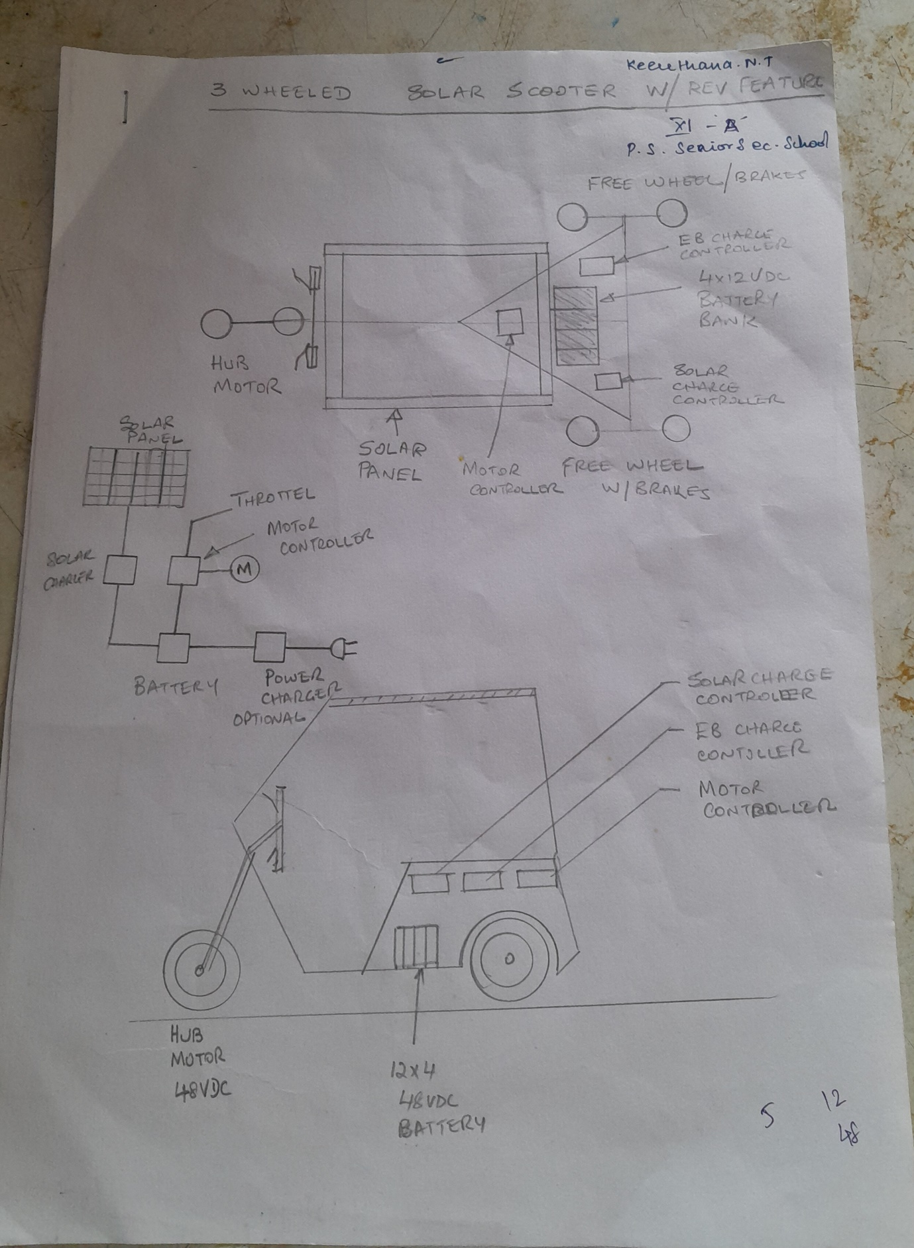

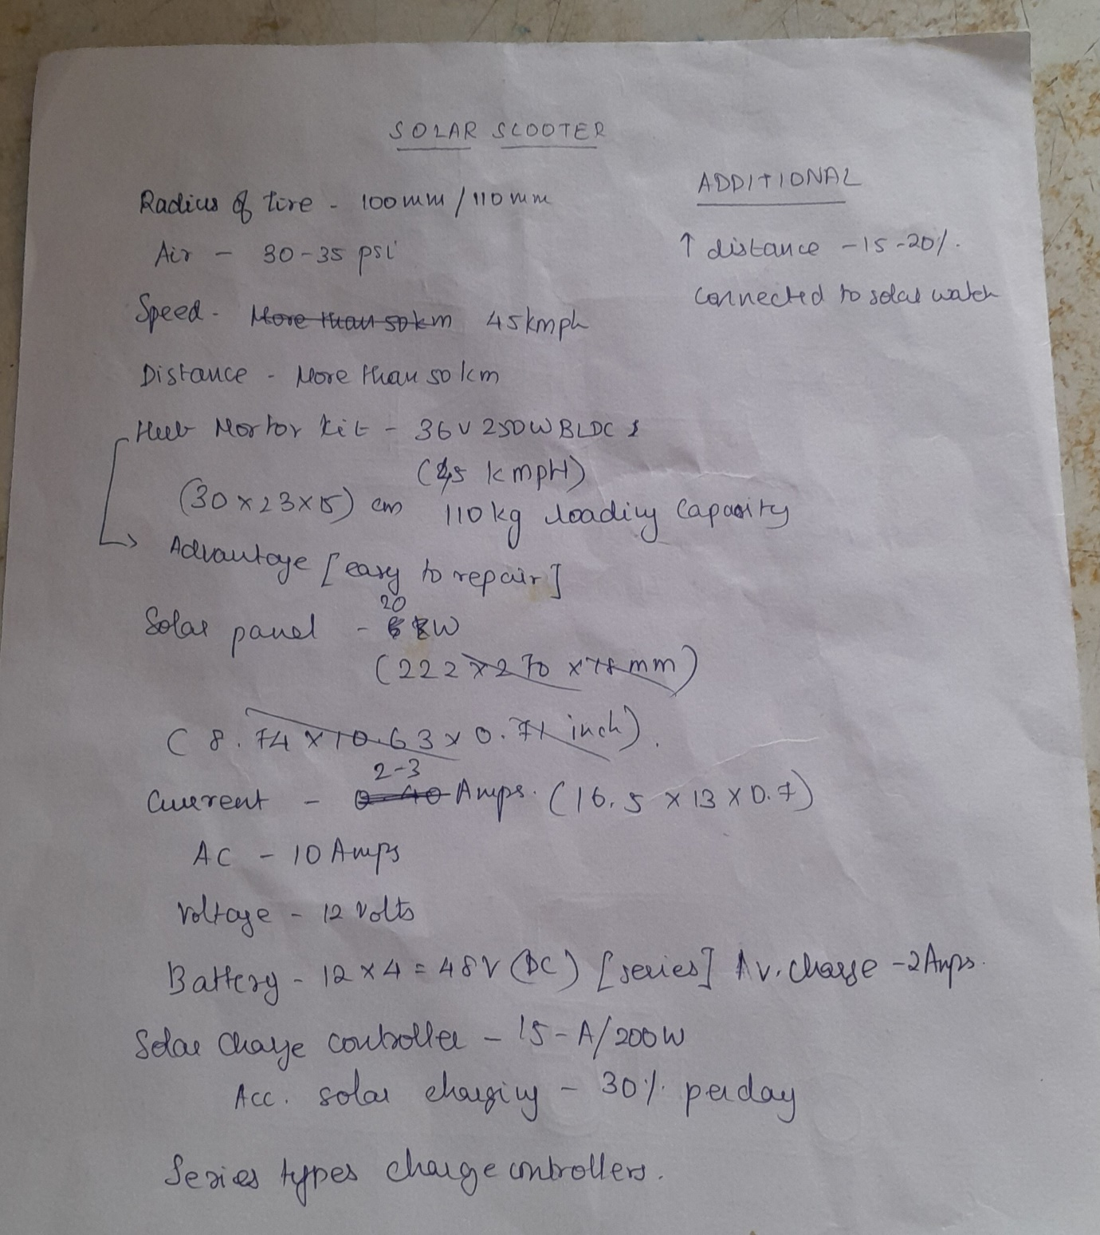

Working –

1. Solar panels are fitted to the roof surface of electric vehicles. The solar panels [photovoltaic cells](https://testbook.com/physics/photovoltaic-cell) transform light energy from the sun’s beams into [electrical energy](https://testbook.com/physics/electrical-power) by absorbing it. The solar cells on the vehicle’s body are intended to store the light energy that has been transformed into storage batteries.
2. A storage battery composed of lithium-ion and nickel-cadmium is used to store the electrical energy created when light energy is converted to it. Free [electrons](https://testbook.com/physics/electron-mass) may be converted by the batteries into energy that can be used to drive a solar vehicle. Solar energy is used to replenish the [battery](https://testbook.com/physics/types-of-battery).
3. With the potential to produce 90 to 175 volts of electricity, solar vehicles can go up to 70 to 90 kilometres on a single charge.

Usefulness to society –

* **Environmental friendly** - Solar scooter produce no emissions. They are extremely environment friendly. This is because they don’t utilise any non-renewable resources, such as fuels. As a result, they don’t release any hazardous toxins or greenhouse gasses.
* **Reduce noise pollution:** The electric motors in this vehicle doesn’t produce noise, this avoids noise pollution.
* **Zero fuel cost:** Since solar panels and battery is used this vehicle doesn’t require usage of fuel resulting in significant fuel savings as compared to traditional vehicle powered by gasoline and diesel, they require less maintenance.
* **Energy accessibility:** The sun serves as a solar vehicle’s primary power source. For later usage as horsepower for automobiles, the solar panels store this light energy.
* **Driving comfort:** Solar vehicles move more quickly and easily since they are composed of lightweight materials.